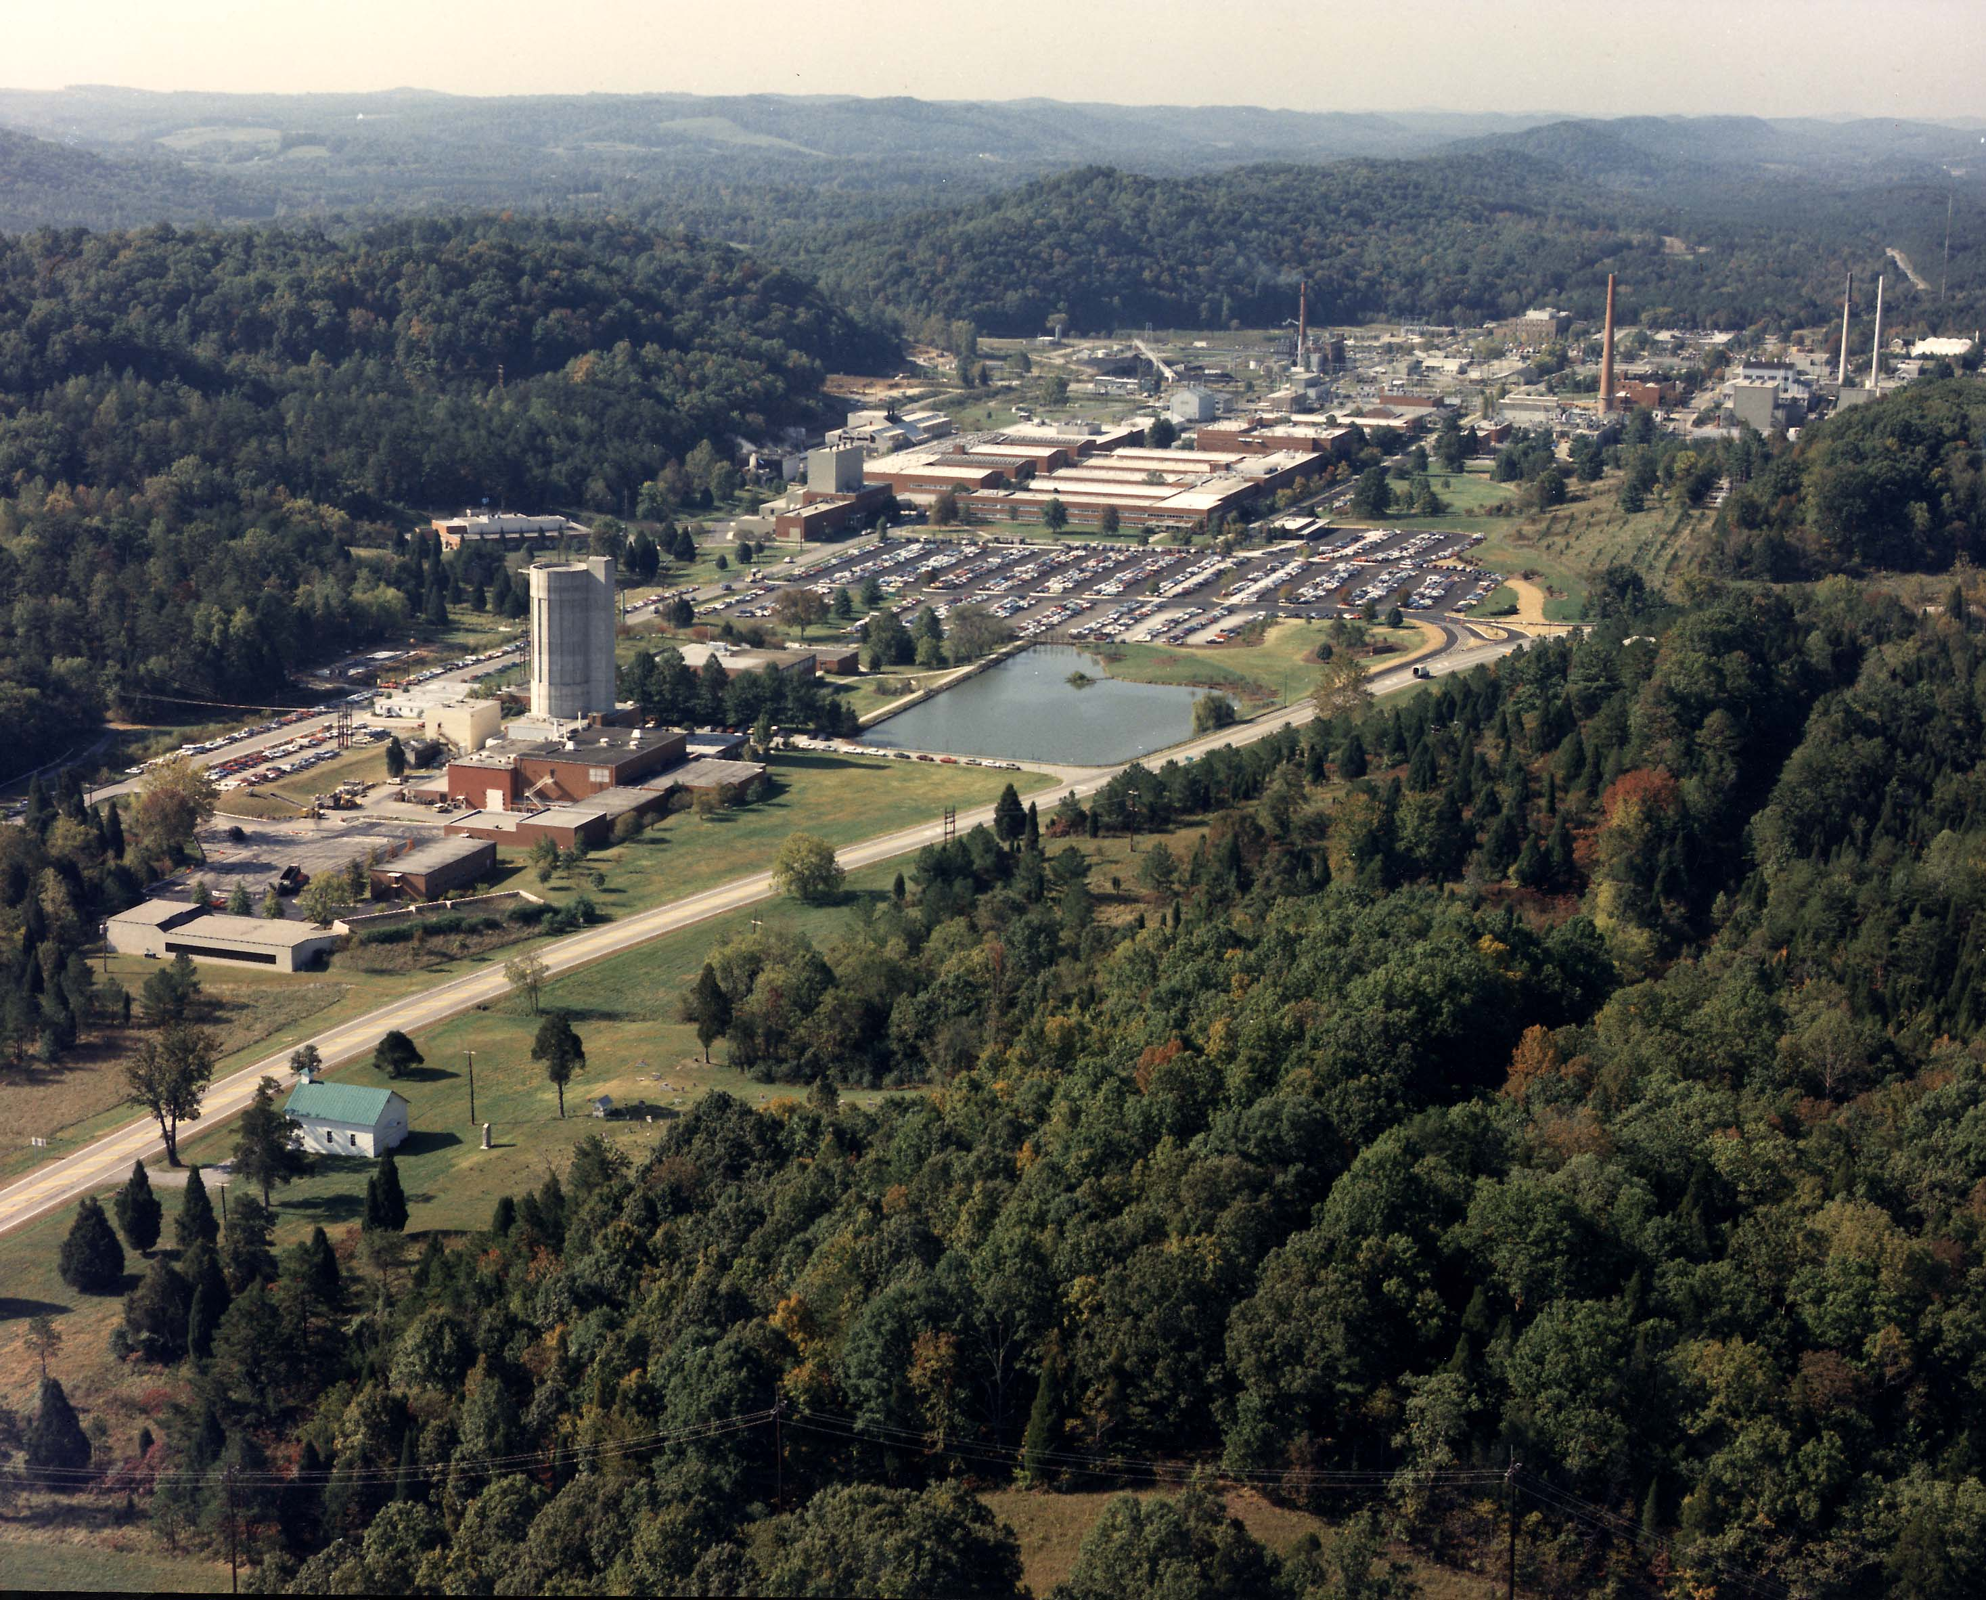

Oak Ridge National Laboratory

Oak Ridge National Laboratory is a multiprogram science and technology national laboratory managed for the United States Department of Energy by UT-Battelle.